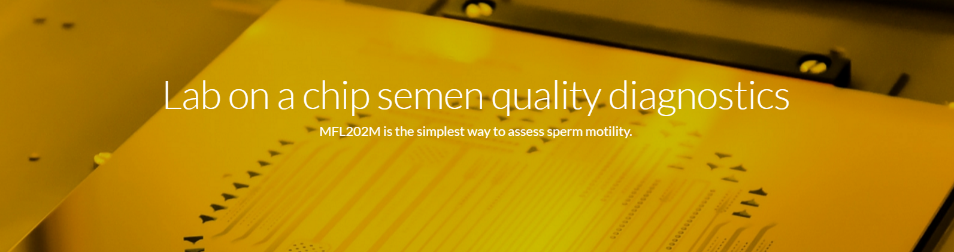

# MFL202M Quick Guide for the Evaluation System v2.4.1

18/09/2016.

## Overview

The sample analysis based on video processing. For real-time capabilities, a video sequence is captured and then processed. During process potential sperms are detected frame by frame and the potential objects are tracked. The tracking keeps and checks the objects speed, direction and feasible path. After tracking, the valid tracks (long enough and has realistic speed and form) are counted and sorted based on speed, linearity, etc. The valid tracks’ statistics are provided as WHO standards.

## Operation

|  |  |
| --- | --- |
| C:\Users\foldesy\AppData\Local\Microsoft\Windows\INetCache\Content.Word\homescreen.jpg | Main menu. With the buttons beside the pictograms you can select an option.  The **Analysis** starts the work with the samples. The **wifi** menu enables to browse non password protected wifi networks around. When the list found, than one of them can be selected by the buttons. If the connection is successful, the IP address of the device is shown.  The **information** page shows the IP address or no connection mark, version, and other details. |

The flow of the measurements is straightforward:

|  |  |
| --- | --- |
| heatingup.jpg | First the sample holder is heated up. If it reaches a certain temperature it goes to the next step.  During this time the slide can be inserted.  The temperature stabilization is fixed for 37 Celsius degree during the measurement period. |
|  |  |
|  | When the temperature is to be stabilized, the sample liquid could be dropped into the slide in the holder (in case of slides and covers, just put in the slide into the holder this time). |
|  |  |
|  | On the next screen the detection type can be selected. See appendix for more information about the type selection. |
|  |  |
|  | Next the area selection. The increasing sized areas are multiples of the smallest window (425x600 um) by 1, 2, 4 times of it. The largest area’s processing could last for 1-2 minutes; it is advised to start experimenting with the smallest selection and use the largest one for more accurate measurements. |
|  |  |
|  | Next the analysis time period is selected by the buttons. It is advised to start experimenting with the smallest selection too. |
|  |  |
|  | Focusing help screen, than the focusing window.  In the window the goal is to fine tune the focusing by the two upper buttons that move the motorized optics. The detected sperm count is shown as hits, which helps to adjust the focus. If the hits are maximized, that means ideal focusing for the track. Then the analysis could be started by the third button. |
|  |  |
|  | Sliders will show the video recording and the processing advance. The analysis time depends on time selection, area and the number of tracked sperms. In worst case it lasts 1-2 minutes. |
|  |  |
|  | Finally the results screen. The counted sperm number, the WHO standard numbers, and the concentration are shown.  **Grade a, Rapid progressive motility (25 μm/s);**  **Grade b, Slow/sluggish progressive motility (5-25 μm/s); sluggish means slow or rapid motion with circular/not linear direction.**  **Grade c, Nonprogressive motility (<5 μm/s)**  **Grade d, Immotility**  **The concentration calculation is based on 20 μm height channels!**  Other metrics can be derived from these values.  THIS is the time to copy the raw video file of the device to the wifi connected PC for further analysis. See next chapter.  Leaving the window the main setup comes again. |

## Accessing of videos

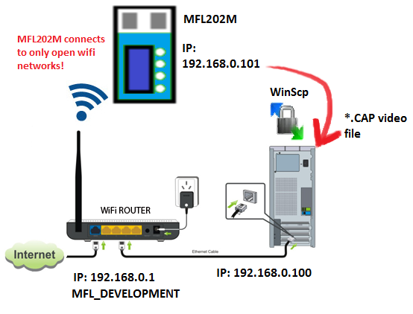

The device’s storage area can be accessed by the wifi connection. If the wifi is enabled on the device than with any SSH protected program using SCP the recorded video can be copied.

In the demo setup the wifi router is called **MFL_DEVELOPMENT, and gives a static address to the device** (192.168.0.101). Using the demo setup’s **winscp.exe and its winscp.ini file, you can access to the files**. The **winscp.ini contains the encrypted password for the device**, when using put the winscp.exe to the same folder as its ini file! If needed, any official winscp distribution works.

When the winscp opens the connection at the **home folder** with no navigating at all, the last recorded video can be seen. It will have a time coded name and .cap extension, like: “2016-09-05T133633.cap”. **The video is accessible when the device is in results screen only!** Afterwards the videos are removed. After returning to another measurement and download the current video, in the **winscp program the use “reload” button** to see the changed video file. After copying the video to a known location in the connected PC, the results screen can be leaved by the lowest button.

## Analysis types

The videos are captured for 5, 10, 30 seconds (can be overwrite in the configuration file) at 24 fps and 800x600 grayscale pixels. The magnification is similar to a 10x microscope objective (1.5 micrometer per pixel)

The object detection is done individually on individual frames. The detection is strongly depends on object size, thus magnification and lens locked. There are two different tracking algorithms on the detected sperms. The first is useful for small, round headed sperms (like human sperms). The second is for oval, larger headed sperms, like bull have. The tracking uses Kalman filter to keep object direction and speed and to predict next position. The filter can handle temporal absence of objects and occlusion. Due to the method’s running time the analysis handles potentially 1000-1200 sperms per full field of view at most, which limits the tracking to around 500 million/ml sperm concentration.

During the statistical evaluation of motility the sperm paths less than 1 second are disclosed. The sperms are counted to show concentration, linearity, speed.

## Known errors

|  |  |  |
| --- | --- | --- |
| *Symptom* | *Reason* | *Solution* |
| Sample holder temperature runs higher than 37 C. | The temperature sensor dislocated. | Call or write to support. |
| Result screen skipped and the main screen appears. |  |  |
| Program freezes on the main screen |  | Restart device |
| Program freezes on consecutive screens | Battery low, and no visual feedback on it. | Connect the charger. |
| Files cannot be accessed. | - Wifi connection not enabled  - Password is missing or wrong | Check information or wifi setup screens, if not connected, than use the main menu’s wifi to connect.  Not the given winscp.exe and ini files are used.  If winscp is connected, push *reload.*  Not in the results screen is the device and the video is removed already. |